11585 JONES BRIDGE RD

JOHNS CREEK GA 30022

CONTACT

PAMELLA J. PRIDGEN CEO
ICSdispatchsvcs@Proton.me
678-600-5965404-494-5018

CERTIFICATIONS & REGISTRATIONS

PSC Code v112

MC- 146-7180

DOT- 394-6315
- CAGE-9JA73

Full-service provider working with a vast network of quality couriers and below are some of the things that set us apart: Competitive rates On time pick-up and delivery Qualified & experienced drivers High safety ratings Communication and updates throughout the freight movement process Honest & Reliable Competent & Resilient High degree of professionalism We know that shippers just want a dependable company to count on and we are that company!
certified minority woman owned business operating in the professional cleaning services industry. We specialize in post construction cleanup, disaster clean up, commercial cleaning, janitorial services and junk, trash & debris removal. No job is too big or too small! We enjoy going beyond the call of duty to put smiles on our customers faces!

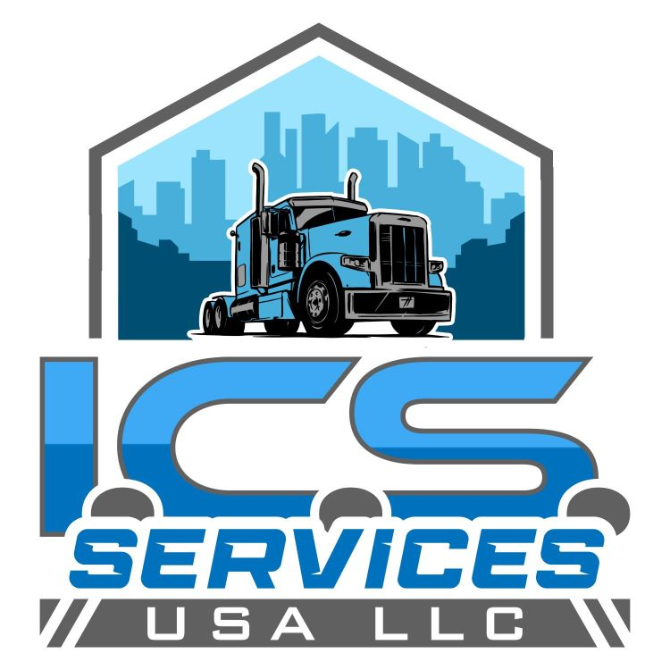

NAICS CODES
492110 Couriers Express Delivery Services SIC 4215 Courier Services (except by air) last mile logistics of intercity courier network, and Georgia, Alabama, South and North Carolina, Mississippi, Tennessee, and Florida.
488991 Medical Supplies Express Delivery Services Nonperishable goods Medical Supplies(except used goods)
561720- Clean up Disaster removal non-hazardous and Construction site & Buildings
488999- All other Transportation Support Activities
Mercedesorg.com Dr. Dale Shepperd,
1800-656-3190

